Overloaded constructor generation in sub class

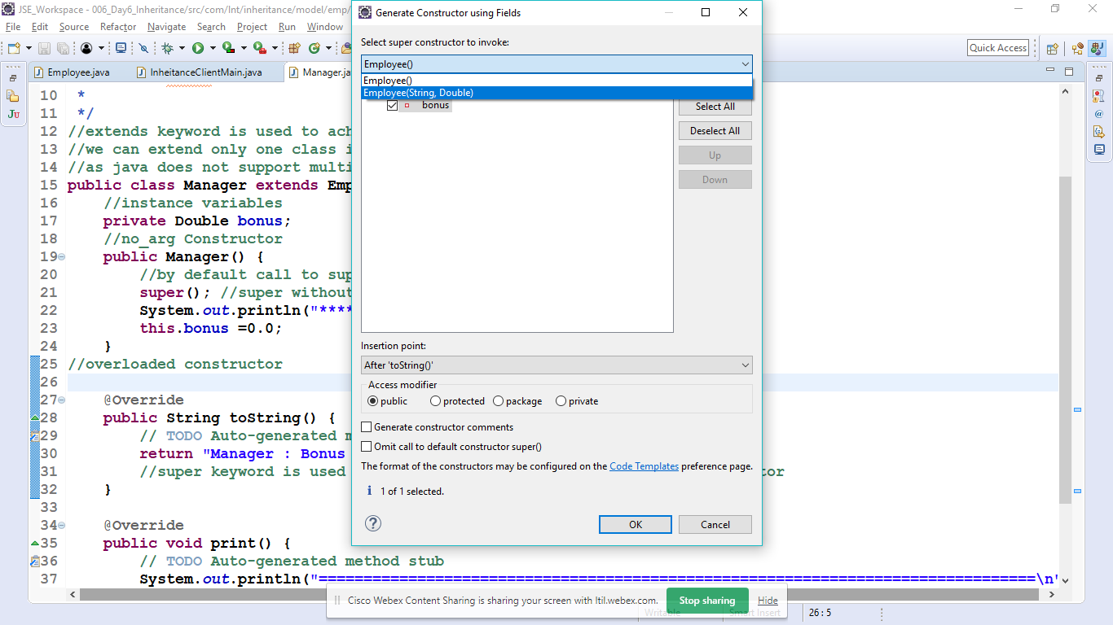

Right click-> generate constructor using field

Select super class overloaded constructor

Hit ok---------------------

Now generate toSTring method in Sub-class/child-class

Right click-> generate toString() method

From inherited method select toString () also